National Parks 

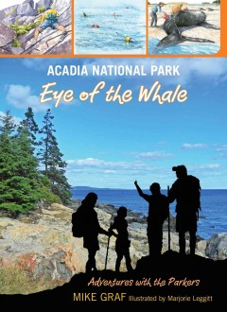

Acadia National Park: Eye of the Whale by Mike [Graf](https://elibrary.richland.lib.wa.us/eg/opac/results?locg=1;detail_record_view=1;no_highlight=1;qtype=author;query=Graf%20Mike) ( J 974.145 GRAF)

This is book one of a series in which the Parker family embarks on an adventure to explore the history, unusual geology, famous sites, plants, and animals of one of America’s National Parks. There are eleven different parks visited in this series.

# 

# https://ipage.ingramcontent.com/ipage/servlet/ibg.common.titledetail.imageloader?ean=9781423642367

All Aboard National Parks: A Wildlife Primer by Hally Meyers (EB MEYERS)

Visit national parks across the United States via train in this wildlife primer board book.

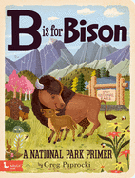

B Is for Bison: A National Parks Primer by Greg Paprocki (EB PAPROCKI)

A collection of illustrations showing amazing features of 26 national parks across the United States.

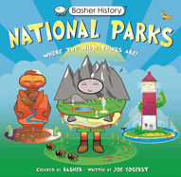

Basher History: National Parks: Where the Wild Things Are! by Joe Yogerst

Invites you to take a journey through some of the United States' most spectacular national parks, recreation areas, preserves. and monuments!

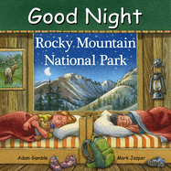

Good Night Rocky Mountain National Park by Adam Gamble (EB GAMBLE)

Highlights the Rocky Mountain National Park’s most treasured landmarks, activities and wildlife.

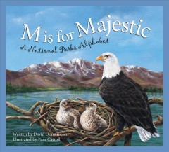

M is for Majestic: A National Parks Alphabet by David [Domeniconi](https://elibrary.richland.lib.wa.us/eg/opac/results?locg=4%3A6;detail_record_view=1;qtype=author;query=Domeniconi%20David)

(J 333.783 DOMENICO)

Tells the history and lore of America’s national parks from Acadia to Zion.

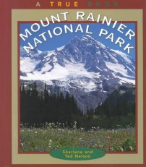

Mount Rainier National Park by Sharlene P. [Nelson](https://elibrary.richland.lib.wa.us/eg/opac/results?locg=4%3A6;detail_record_view=1;qtype=author;query=Nelson%20Sharlene%20P) ( J 979.7 NEL)

Describes the history, landscape, wildlife, and activities for visitors at Washington's Mount Rainier National Park.

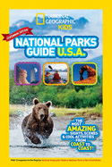National Geographic Kids National Parks Guide USA Centennial Edition: The Most Amazing Sights, Scenes, and Cool Activities from Coast to Coast!

Kids' companion to the popular National Geographic guide to national parks of the United States.

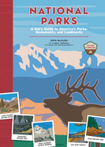

National Parks: A Kid's Guide to America's Parks, Monuments, and Landmarks (Revised, Updated) by Erin McHugh  
Explores the wonders and weirdness of more than 75 U.S. parks, monuments, and landmarks.

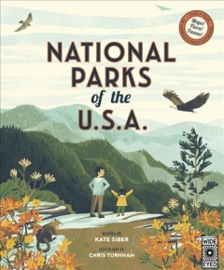

National Parks of the U.S.A. by Kate [Sibe](https://elibrary.richland.lib.wa.us/eg/opac/results?locg=1;detail_record_view=1;no_highlight=1;query=Siber%20Kate;qtype=author)r  (J 363.6809 SIBER)

Visits 21 of the National Parks, sharing the most magnificent and sacred places of each. Includes maps and information about their plants and animals.

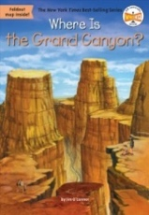Where is the Grand Canyon? by Jim O’Connor (J 979.132 O’Connor)

Although the Grand Canyon in Arizona is not the biggest canyon in the world, because of the spectacular colors in the rock layers and fascinating formations of boulders, buttes, and mesas, it is known as one of the Seven Natural Wonders of the World.

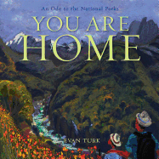You Are Home: An Ode to the National Parks by Evan Turk (E TURK)

Showcases the beauty and importance of the National Parks in this gorgeous picture book.